IE 575 Homework 6

Eric Smith

2025-07-04

1. Explore the Data Set and Initial C5.0 Model
Data Exploration
# Load the dataset
file_path <- "Patient_Data.xlsx"
patient_data <- read_excel(file_path, sheet = "Patient Data")

# Check for missing values and duplicates
na_counts <- sapply(patient_data, function(x) sum(is.na(x)))
print("Missing Values in Each Column:")
## [1] "Missing Values in Each Column:"
print(na_counts)
## age gender diabetes smoker active
## 0 0 0 0 0
## obesity heartattack_s bp cholesteral
## 0 0 0 0
duplicate_count <- sum(duplicated(patient_data))
print(paste("Number of Duplicate Rows:", duplicate_count))
## [1] "Number of Duplicate Rows: 4492"
# Clean and factorize
patient_data <- patient_data[!duplicated(patient_data), ]

categorical_vars <- c("gender", "diabetes", "smoker", "active", "obesity", "heartattack_s", "bp", "cholesteral")
patient_data[categorical_vars] <- lapply(patient_data[categorical_vars], factor)

# Overview
summary(patient_data)
## age gender diabetes smoker active obesity
## Min. :45.00 Female:1766 No :3024 No :2398 No :1851 No :2298
## 1st Qu.:55.00 Male :1740 Yes: 482 Yes:1108 Yes:1655 Yes:1208
## Median :63.00
## Mean :63.28
## 3rd Qu.:71.00
## Max. :89.00
## heartattack_s bp cholesteral
## No :1445 Hypertension:1190 Highl :1566
## Yes:2061 Hypotension : 665 Normal:1940
## Normal :1651
##
##
##
str(patient_data)
## tibble [3,506 × 9] (S3: tbl_df/tbl/data.frame)
## $ age : num [1:3506] 54 64 63 67 76 69 67 74 69 54 ...
## $ gender : Factor w/ 2 levels "Female","Male": 1 1 1 2 2 2 2 2 2 1 ...
## $ diabetes : Factor w/ 2 levels "No","Yes": 1 1 1 1 1 1 2 1 1 1 ...
## $ smoker : Factor w/ 2 levels "No","Yes": 1 1 1 2 1 1 2 1 2 2 ...
## $ active : Factor w/ 2 levels "No","Yes": 2 1 1 1 1 1 2 1 2 1 ...
## $ obesity : Factor w/ 2 levels "No","Yes": 1 1 1 1 1 1 1 2 1 1 ...
## $ heartattack_s: Factor w/ 2 levels "No","Yes": 1 2 2 1 1 1 2 2 1 2 ...
## $ bp : Factor w/ 3 levels "Hypertension",..: 1 3 3 2 2 3 1 3 3 3 ...
## $ cholesteral : Factor w/ 2 levels "Highl","Normal": 2 2 1 1 2 2 2 2 1 1 ...
# Identify numeric variables
numeric_vars <- sapply(patient_data, is.numeric)
num_cols <- names(patient_data)[numeric_vars]

# List of categorical variables
cat_vars <- c("gender", "diabetes", "smoker", "active", "obesity", "bp", "cholesteral")

for (cat in cat_vars) {
p <- ggplot(patient_data, aes_string(x = cat, fill = "heartattack_s")) +
geom_bar(position = "fill") +
scale_y_continuous(labels = scales::percent) +
labs(title = paste("Heart Attack Rate by", cat),
y = "Proportion", x = cat, fill = "Heart Attack") +
theme_minimal()
print(p)
}
## Warning: `aes_string()` was deprecated in ggplot2 3.0.0.
## ℹ Please use tidy evaluation idioms with `aes()`.
## ℹ See also `vignette("ggplot2-in-packages")` for more information.
## This warning is displayed once every 8 hours.
## Call `lifecycle::last_lifecycle_warnings()` to see where this warning was
## generated.
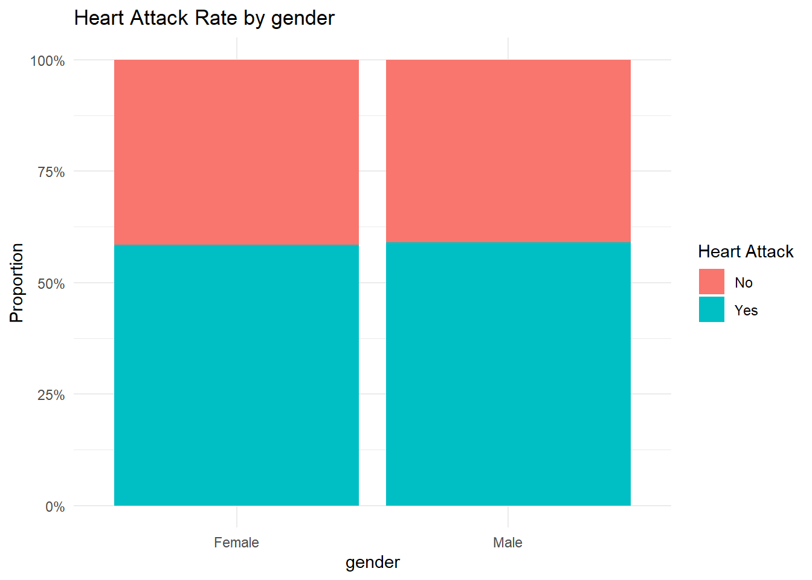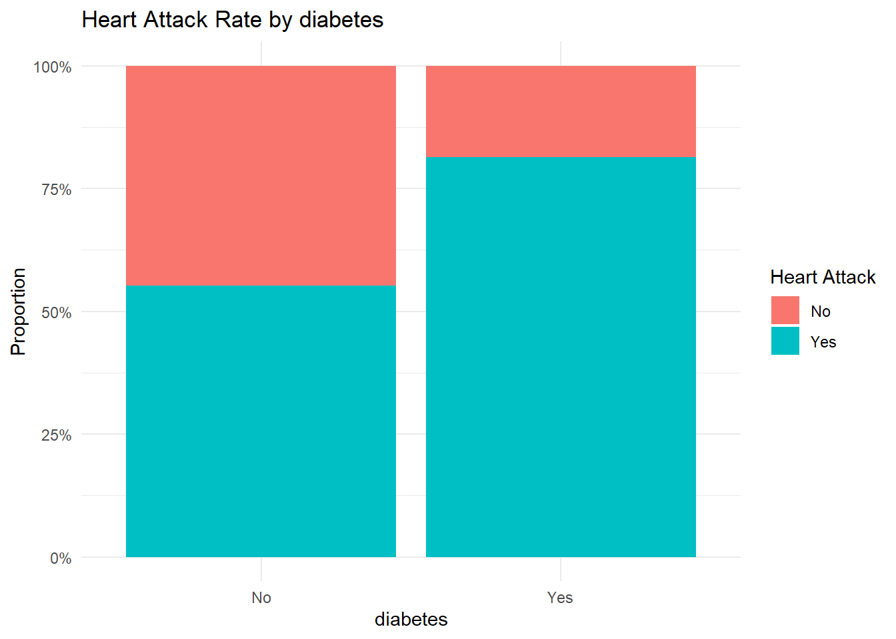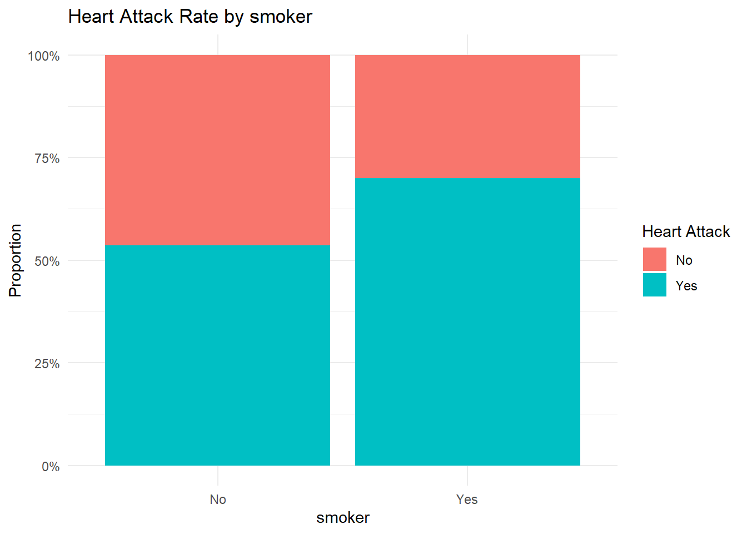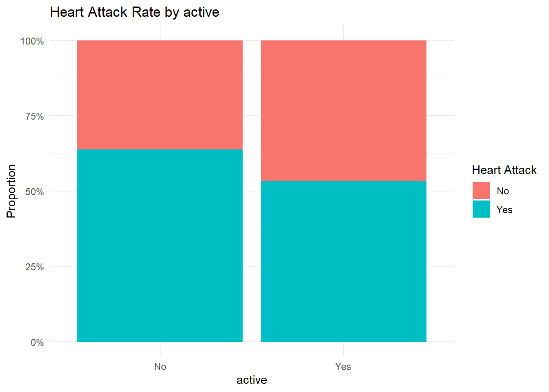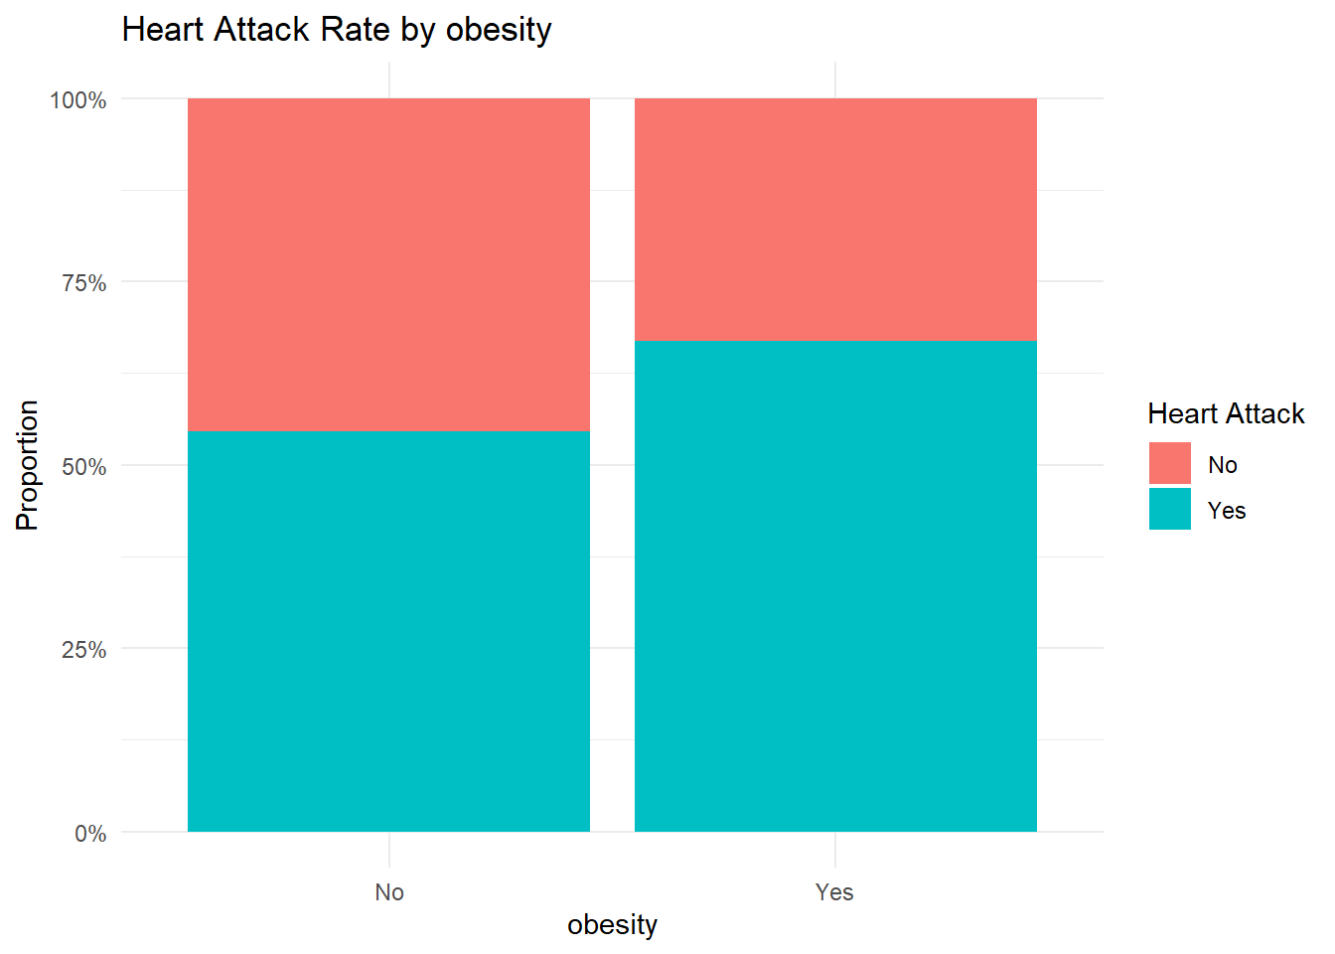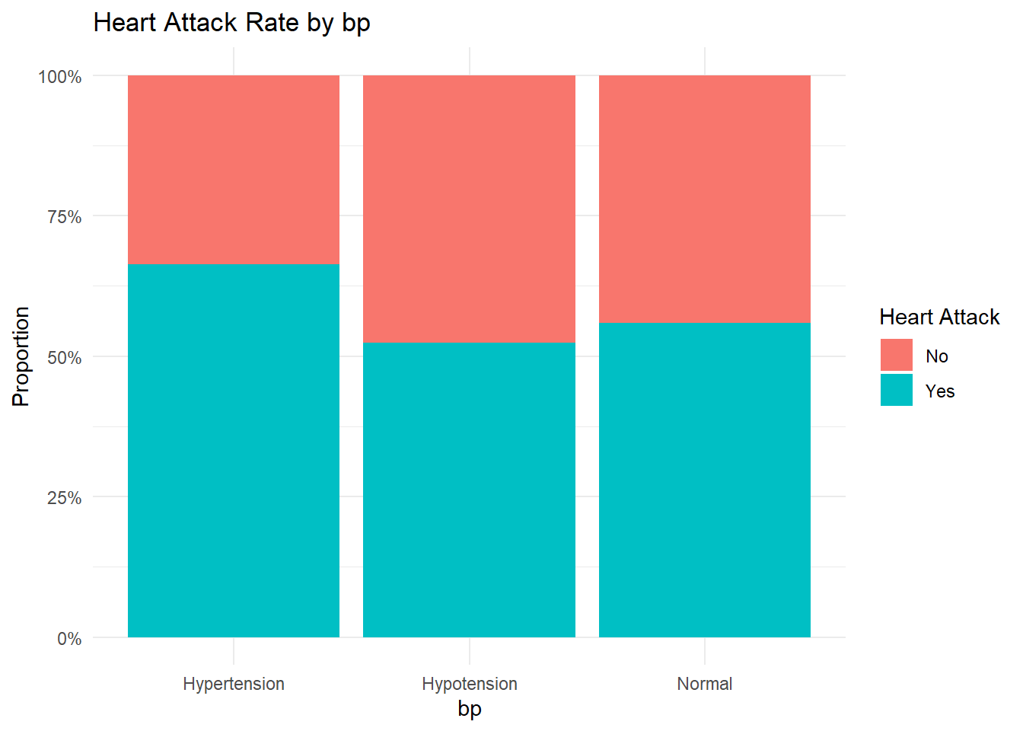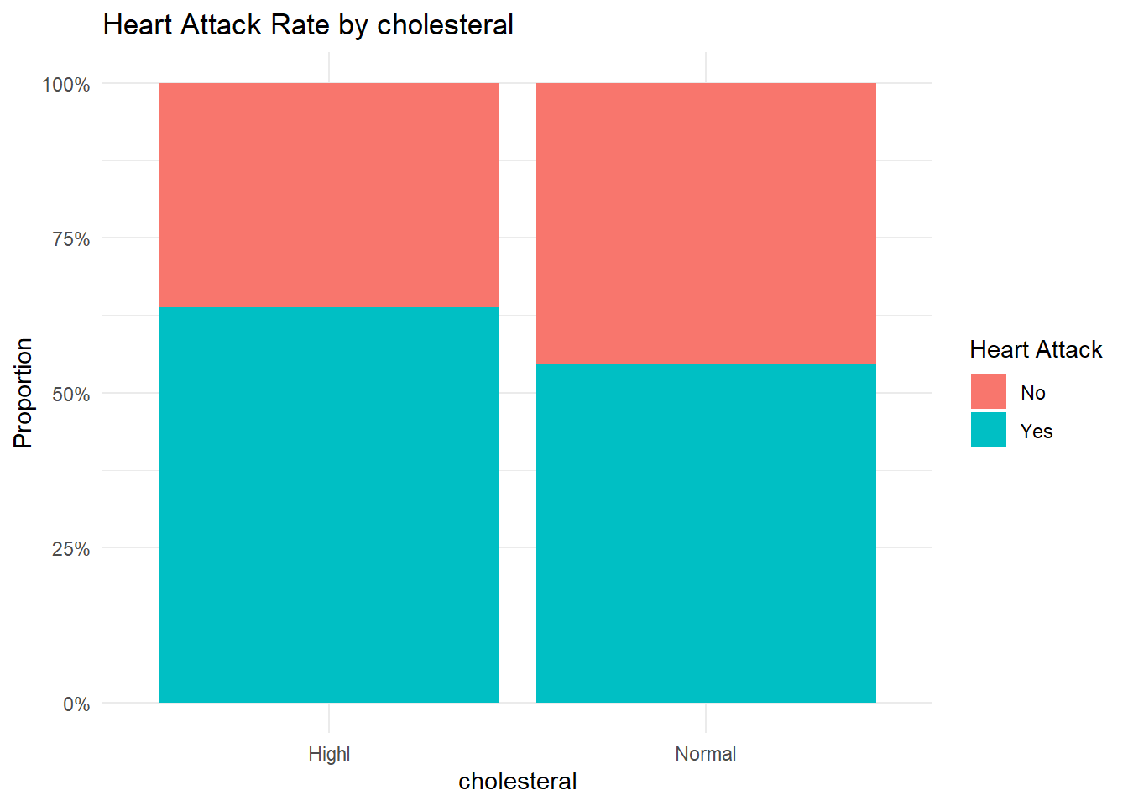
Initial Data Observations
Initial look at the data revealed that there were no missing values, but that there were 4,492 duplicate rows. Those were kept in the dataset as they may not be duplicate patients but similar sets of observations.
Variables include age, which is continuous and numeric, and a number of classification variables, such as gender with female and male; diabetes, smoker, active, obesity, heartattack_s (the target variable), all with “Yes” or “No” classes; blood pressure (bp), with three classes that include “Hpypertension,” “Hypotension,” and “Normal”; and and cholesterol with two classes that include “Highl,” and “Normal”.
As expected, the classic indicators shown in the bar charts above show that expected risks such as diabetes and being a smoker have more observations of heart attack risk.

C5.0 Model (No Partition)
model <- C5.0(heartattack_s ~ ., data = patient_data)
summary(model)
##
## Call:
## C5.0.formula(formula = heartattack_s ~ ., data = patient_data)
##
##
## C5.0 [Release 2.07 GPL Edition] Fri Jul 4 11:00:35 2025
## -------------------------------
##
## Class specified by attribute `outcome'
##
## Read 3506 cases (9 attributes) from undefined.data
##
## Decision tree:
##
## diabetes = Yes: Yes (482/90)
## diabetes = No:
## :...smoker = Yes:
## :...age > 60: Yes (539/129)
## : age <= 60:
## : :...bp = Hypertension: Yes (129/37)
## : bp in {Hypotension,Normal}:
## : :...obesity = Yes: Yes (89/34)
## : obesity = No:
## : :...active = No: Yes (101/48)
## : active = Yes: No (126/52)
## smoker = No:
## :...age <= 55: No (513/177)
## age > 55:
## :...obesity = No:
## :...active = No: Yes (501/237)
## : active = Yes: No (486/223)
## obesity = Yes:
## :...age > 71: Yes (159/38)
## age <= 71:
## :...active = No: Yes (207/72)
## active = Yes:
## :...gender = Female: No (82/36)
## gender = Male: Yes (92/41)
##
##
## Evaluation on training data (3506 cases):
##
## Decision Tree
## ----------------
## Size Errors
##
## 13 1214(34.6%) <<
##
##
## (a) (b) <-classified as
## ---- ----
## 719 726 (a): class No
## 488 1573 (b): class Yes
##
##
## Attribute usage:
##
## 100.00% diabetes
## 86.25% age
## 86.25% smoker
## 52.57% obesity
## 45.49% active
## 12.69% bp
## 4.96% gender
##
##
## Time: 0.0 secs
C5imp(model, metric = "usage")
## Overall
## diabetes 100.00
## age 86.25
## smoker 86.25
## obesity 52.57
## active 45.49
## bp 12.69
## gender 4.96
## cholesteral 0.00
# Predict and confusion matrix
preds <- predict(model, patient_data)
c50_cm <- table(predicted = preds, actual = patient_data$heartattack_s)
c50_accuracy <- mean(preds == patient_data$heartattack_s)

print(c50_cm)
## actual
## predicted No Yes
## No 719 488
## Yes 726 1573
paste("C5.0 Accuracy:", round(c50_accuracy * 100, 2), "%")
## [1] "C5.0 Accuracy: 65.37 %"
plot(model, main = "C5.0 Tree for Heart Attack Prediction")
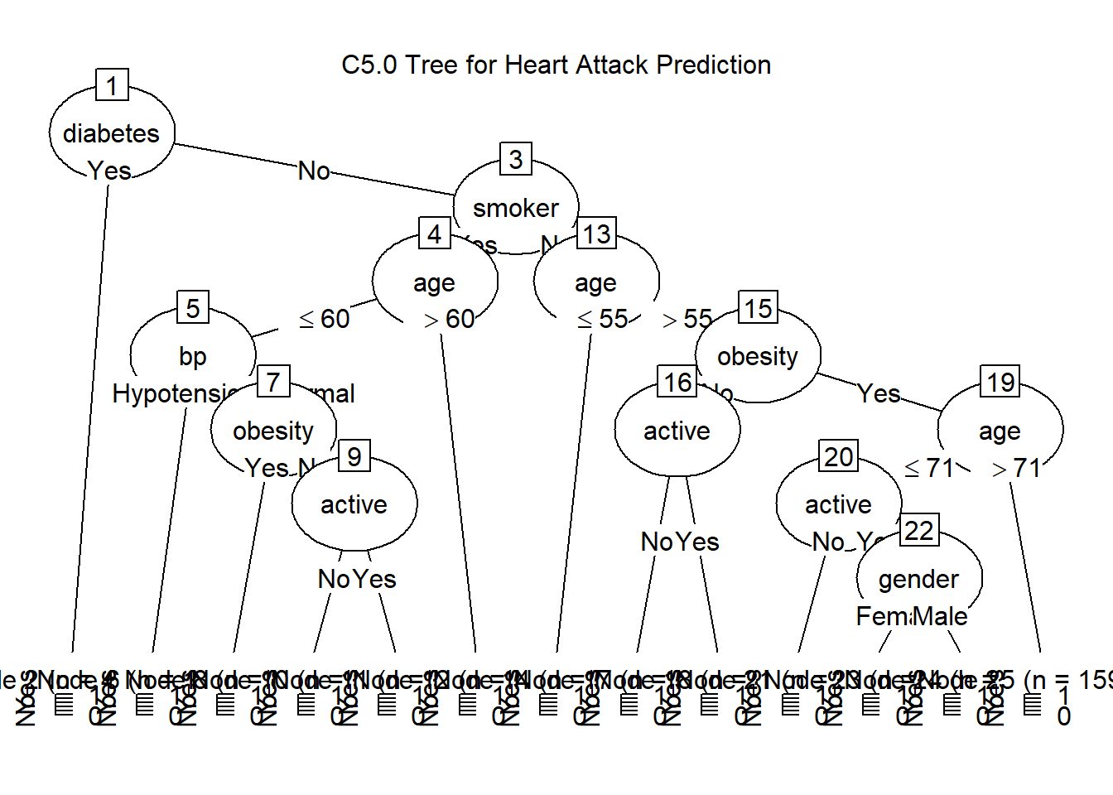
C 5.0 Model Observations
From this data, the C5.0 model built a decision tree with 13 splits based on patterns in the data. It correctly predicted heart attack risk about 65% of the time, which is moderate accuracy. The tree was trained on 3,506 cases and made its decisions by breaking the data into smaller groups based on the most useful factors.
The model tended to predict “Yes” (heart attack) more often, and while it did well at catching those who were at risk (1,573 correct), it struggled with false alarms — 726 people were flagged as high risk when they actually weren’t. This shows a bias toward the “Yes” class.
The first and most important factor in the tree was diabetes, which was used in every decision path. It was followed by age, smoking, obesity, and activity level. These are all logical indicators of heart health. Other factors like blood pressure and gender played a smaller role, and cholesterol surprisingly wasn’t used at all, meaning it didn’t help the model make better decisions in this case.
Detailed in Lesson 8 and the text, the model’s approach is based on something called a greedy strategy — it makes one split at a time based on which variable gives the biggest gain in decision clarity, using a measure called entropy. In short, it keeps choosing the best local option without looking ahead.
Overall, the tree is mostly what we’d expect to see: people who are older, diabetic, less active, or smokers are more likely to be predicted as high risk.

2. CART Comparison
cart_model <- rpart(heartattack_s ~ ., data = patient_data, method = "class")
cart_preds <- predict(cart_model, patient_data, type = "class")
cart_cm <- table(predicted = cart_preds, actual = patient_data$heartattack_s)
cart_accuracy <- mean(cart_preds == patient_data$heartattack_s)

print(cart_cm)
## actual
## predicted No Yes
## No 599 400
## Yes 846 1661
paste("CART Accuracy:", round(cart_accuracy * 100, 2), "%")
## [1] "CART Accuracy: 64.46 %"
rpart.plot(cart_model, main = "CART Tree for Heart Attack Prediction")
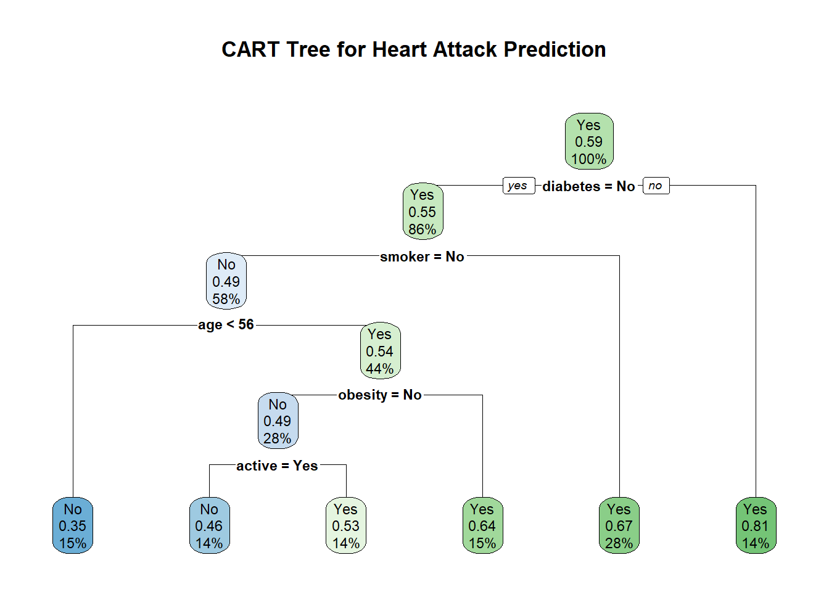
C5.0 vs. CART Observations
The CART model reached 64.46% accuracy, which is slightly lower than the 65.37% we saw with the C5.0 model. Like before, this means the model predicted heart attack risk correctly about two-thirds of the time.
Looking at the confusion matrix, CART correctly identified 1,661 people who had a heart attack, but it also had a high number of false positives — 846 people were incorrectly flagged as at risk. It also missed 400 actual cases. Like the C5.0 model, it leans toward predicting “Yes,” probably because the dataset contains more positive outcomes than negative.
CART builds its tree using binary splits versus multiple splits like the C5.0 model does. It tends to choose the variable that creates the most clearly separated groups using the Gini index as mentioned in Lesson 8. Compared to C5.0, CART usually produces simpler trees with fewer splits and doesn’t allow multiple branches from a single decision point. This makes the tree easier to read, but sometimes less flexible. C5.0, on the other hand, uses entropy to find the best splits and can create more complex trees with multiple branches, which can capture more nuances in the data. Entropy is a measure of uncertainty or disorder, and C5.0 uses it to find the splits that reduce uncertainty the most.
In the CART model, the first and most important factor was diabetes — people with diabetes were almost always predicted to be at high risk. Other key splits involved smoking, age, obesity, and physical activity, which are all consistent with what we’d expect in a heart risk scenario.
So while both models use similar features and perform about the same, C5.0 slightly outperforms the CART model here in terms of accuracy and flexibility, although it is plain to see based on the complexity of the trees that the CART model is easier to interpret. The C5.0 model, with its multiple splits and more complex structure, captures more nuances in the data, which may explain its slightly higher accuracy.

3. Partitioned C5.0 Model
set.seed(266)
partition <- createDataPartition(patient_data$heartattack_s, p = 0.80, list = FALSE)
train_data <- patient_data[partition, ]
test_data <- patient_data[-partition, ]

c50_train_model <- C5.0(heartattack_s ~ ., data = train_data)
c50_test_preds <- predict(c50_train_model, test_data)
c50_test_cm <- table(predicted = c50_test_preds, actual = test_data$heartattack_s)
c50_test_accuracy <- mean(c50_test_preds == test_data$heartattack_s)

print(c50_test_cm)
## actual
## predicted No Yes
## No 166 147
## Yes 123 265
paste("C5.0 Test Accuracy:", round(c50_test_accuracy * 100, 2), "%")
## [1] "C5.0 Test Accuracy: 61.48 %"
plot(c50_train_model, main = "Partitioned C5.0 Tree")
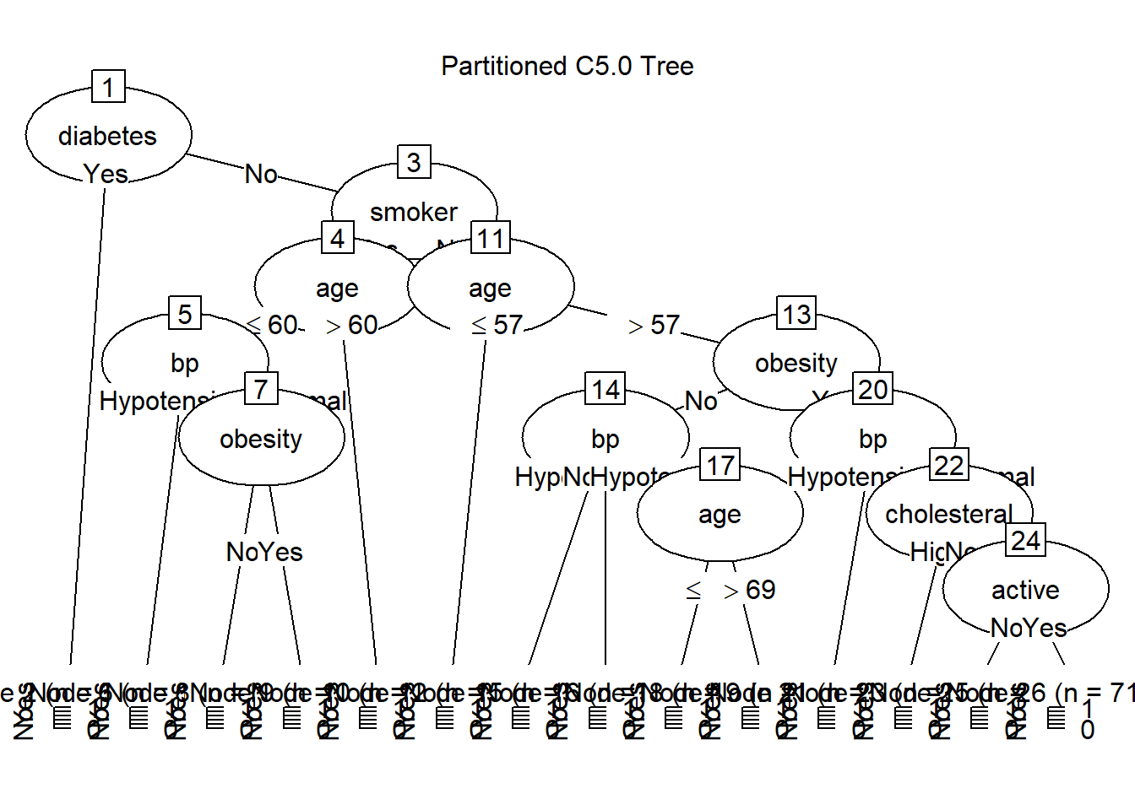
# Function to calculate entropy of a binary vector
entropy <- function(vec) {
probs <- table(vec) / length(vec)
-sum(probs * log2(probs + 1e-10)) # small offset to avoid log(0)
}

# Function to calculate information gain of an attribute
information_gain <- function(data, target_col, attribute_col) {
total_entropy <- entropy(data[[target_col]])
values <- unique(data[[attribute_col]])

weighted_entropy <- 0
for (val in values) {
subset <- data[data[[attribute_col]] == val, ]
weight <- nrow(subset) / nrow(data)
weighted_entropy <- weighted_entropy + weight * entropy(subset[[target_col]])
}

gain <- total_entropy - weighted_entropy
return(gain)
}

# Categorical predictors
cat_vars <- c("gender", "diabetes", "smoker", "active", "obesity", "bp", "cholesteral")

# Calculate gain for each
gain_results <- data.frame(
Attribute = cat_vars,
Gain = sapply(cat_vars, function(attr) information_gain(patient_data, "heartattack_s", attr))
)

# Sort and print
gain_results <- gain_results[order(-gain_results$Gain), ]
print(gain_results)
## Attribute Gain
## diabetes diabetes 2.632730e-02
## smoker smoker 1.752261e-02
## obesity obesity 1.041221e-02
## bp bp 9.452868e-03
## active active 8.212603e-03
## cholesteral cholesteral 6.052118e-03
## gender gender 2.561895e-05
summary(c50_train_model)
##
## Call:
## C5.0.formula(formula = heartattack_s ~ ., data = train_data)
##
##
## C5.0 [Release 2.07 GPL Edition] Fri Jul 4 11:00:36 2025
## -------------------------------
##
## Class specified by attribute `outcome'
##
## Read 2805 cases (9 attributes) from undefined.data
##
## Decision tree:
##
## diabetes = Yes: Yes (388/75)
## diabetes = No:
## :...smoker = Yes:
## :...age > 60: Yes (436/104)
## : age <= 60:
## : :...bp = Hypertension: Yes (101/27)
## : bp in {Hypotension,Normal}:
## : :...obesity = No: No (185/86)
## : obesity = Yes: Yes (76/29)
## smoker = No:
## :...age <= 57: No (499/175)
## age > 57:
## :...obesity = No:
## :...bp = Hypertension: Yes (241/104)
## : bp = Normal: No (312/151)
## : bp = Hypotension:
## : :...age <= 69: No (98/37)
## : age > 69: Yes (77/31)
## obesity = Yes:
## :...bp = Hypertension: Yes (121/29)
## bp in {Hypotension,Normal}:
## :...cholesteral = Highl: Yes (118/39)
## cholesteral = Normal:
## :...active = No: Yes (82/32)
## active = Yes: No (71/30)
##
##
## Evaluation on training data (2805 cases):
##
## Decision Tree
## ----------------
## Size Errors
##
## 14 949(33.8%) <<
##
##
## (a) (b) <-classified as
## ---- ----
## 686 470 (a): class No
## 479 1170 (b): class Yes
##
##
## Attribute usage:
##
## 100.00% diabetes
## 86.17% age
## 86.17% smoker
## 52.83% bp
## 49.23% obesity
## 9.66% cholesteral
## 5.45% active
##
##
## Time: 0.0 secs
Partioned C5.0 Observations
After splitting the data 80/20 into training and test sets, the C5.0 model achieved 61.48% accuracy on the test data. This is noticeably lower than the 65.37% accuracy from the full model. That drop suggests the original model may have been overfitting — it performed better on the data it was trained on than on new, unseen data.
The confusion matrix shows that the model still identifies more true positives (265) than false negatives (147), but it also misclassifies 123 people as at risk who aren’t, and misses 147 who actually are. So while the general trend remains similar, the reliability is reduced when applied to new data.
The tree structure here is slightly different from the full data version, with similar top-level splits but some variation deeper in the tree, especially with the use of cholesteral and active further down. This reinforces that model behavior can shift depending on the training sample.
Manual Gain Calculation and Tree Split Validation
I also followed the gain formula provided in Lesson 8 and implemented it as an R function to calculate the gain for each categorical variable in the dataset. Then I compared these results to the splits produced by the C5.0 model summary to check for alignment. What I found was that the tree’s behavior is consistent with the gain values — confirming that the model is applying the entropy logic detailed in the lesson.
Specifically, diabetes had the highest gain and was also chosen as the root split in the tree. This makes sense: the more a variable helps separate “Yes” from “No” cases, the more useful it is to the model. Other variables like smoker, bp, and obesity followed in both gain ranking and in their use in the tree — all appearing high up in the branches. Cholesteral and active had lower gain and appeared later or less frequently, which the model summary also confirms.
One interesting note is that while age wasn’t part of the gain calculation because it’s numeric, it was still used frequently in the model (86% of cases). This shows that C5.0 handles numeric splits automatically and considers them in the decision tree.
We also see that gender was effectively excluded by the model as we see it was pruned in the model diagram. It had a near-zero Gain score and was never used in any of the tree’s branches. This indicates that, in this dataset, gender does not contribute meaningful information for predicting heart attack status.
Overall, this comparison confirmed that what we’re seeing in the C5.0 output — including its structure and decision rules — reflects the gain and entropy calcuations from Lesson 8. It was helpful to see how those concepts are actually applied in a real model.
Improving the C5.0 Model
I researched other data science websites to follow up on ideas for improving the C5.0 model. One way to do this is called boosting, which makes use of seting more trials as well as choosing the best split through winnowoing (see reference to C5.0: An Informal Tutorial, 2024, below). This allows the model to learn from its mistakes and adjust its predictions based on previous errors, which can lead to better performance on new data.

Example C5.0 Tuning Through Boosting
c50_tuned <- C5.0(heartattack_s ~ ., data = train_data, trials = 10, control = C5.0Control(winnow = TRUE))
c50_tuned_preds <- predict(c50_tuned, test_data)
c50_tuned_cm <- table(predicted = c50_tuned_preds, actual = test_data$heartattack_s)
c50_tuned_accuracy <- mean(c50_tuned_preds == test_data$heartattack_s)

print(c50_tuned_cm)
## actual
## predicted No Yes
## No 118 95
## Yes 171 317
paste("Tuned C5.0 Accuracy:", round(c50_tuned_accuracy * 100, 2), "%")
## [1] "Tuned C5.0 Accuracy: 62.05 %"
plot(c50_tuned, main = "Boosted C5.0 Tree with Winnowing")
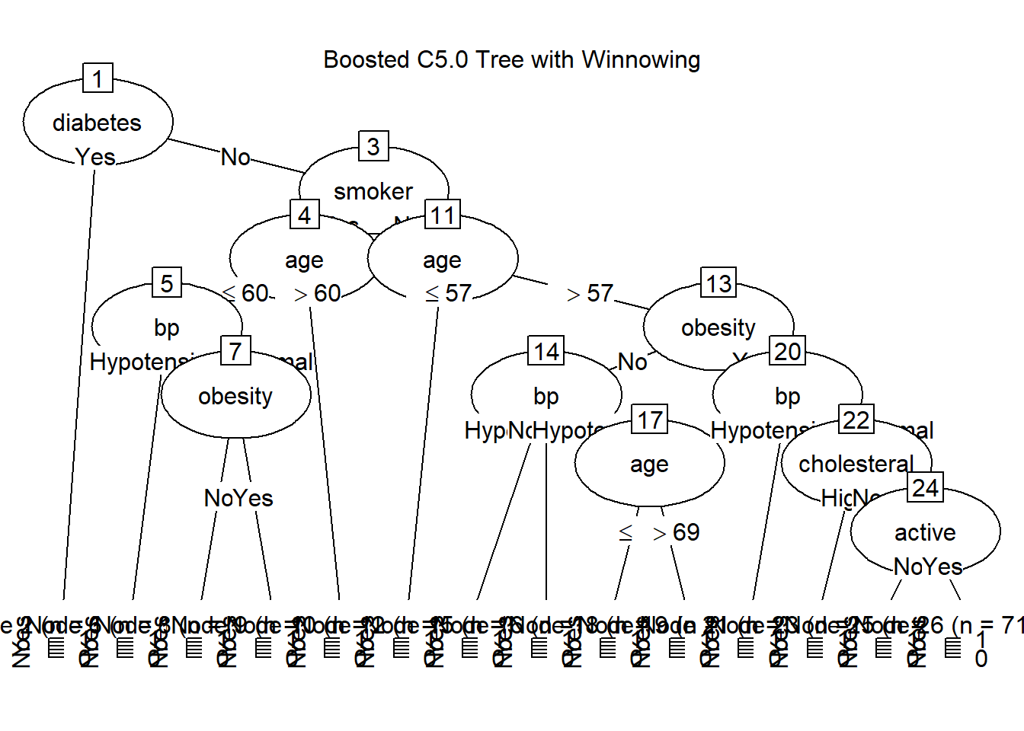
Tuned Example C5.0 Model Observations
After making some improvements to the model — by asking it to try harder through running 10 rounds instead of just one and letting it choose which variables matter most (defined winnowing) — we saw a small bump in accuracy on the test data, from 61.48% to 62.05%.
This means the model got a little better at correctly identifying patients who had a heart attack. Specifically, it correctly predicted 317 heart attacks, which is more than before, though it also made a few more wrong guesses about patients who didn’t have one.
These changes make the model more flexible and able to learn from its mistakes — kind of like going through a few extra rounds of practice. It’s not a huge improvement, but it suggests we’re heading in the right direction.
While it still doesn’t match the accuracy from using the full dataset, this tuned version is better at handling new data and avoids being too tailored to the training examples. That’s a good sign that it’s learning useful patterns, not just memorizing.
Reference:
- C5.0: An Informal Tutorial. (2024). https://storm.cis.fordham.edu/~gweiss/dmrg/c5-tutorial.html

Appendix: Full Code
---
title: "IE 575 Homework 6"
author: "Eric Smith"
date: "`r Sys.Date()`"
output: html_document
---

```{r setup, include=FALSE}
knitr::opts_chunk$set(echo = TRUE)
```

# 1. Explore the Data Set and Initial C5.0 Model

**Data Exploration**

```{r data-exploration, include=FALSE}
# Load necessary libraries
if (!requireNamespace("caret", quietly = TRUE)) install.packages("caret")
if (!requireNamespace("C50", quietly = TRUE)) install.packages("C50")
if (!requireNamespace("readxl", quietly = TRUE)) install.packages("readxl")

library(caret)
library(C50)
library(readxl)
library(ggplot2)
library(dplyr)
library(rpart)
library(rpart.plot)
library(pROC)
```

```{r}

# Load the dataset
file_path <- "Patient_Data.xlsx"
patient_data <- read_excel(file_path, sheet = "Patient Data")

# Check for missing values and duplicates
na_counts <- sapply(patient_data, function(x) sum(is.na(x)))
print("Missing Values in Each Column:")
print(na_counts)

duplicate_count <- sum(duplicated(patient_data))
print(paste("Number of Duplicate Rows:", duplicate_count))

# Clean and factorize
patient_data <- patient_data[!duplicated(patient_data), ]

categorical_vars <- c("gender", "diabetes", "smoker", "active", "obesity", "heartattack_s", "bp", "cholesteral")
patient_data[categorical_vars] <- lapply(patient_data[categorical_vars], factor)

# Overview
summary(patient_data)
str(patient_data)

# Identify numeric variables
numeric_vars <- sapply(patient_data, is.numeric)
num_cols <- names(patient_data)[numeric_vars]

# List of categorical variables
cat_vars <- c("gender", "diabetes", "smoker", "active", "obesity", "bp", "cholesteral")

for (cat in cat_vars) {
p <- ggplot(patient_data, aes_string(x = cat, fill = "heartattack_s")) +
geom_bar(position = "fill") +
scale_y_continuous(labels = scales::percent) +
labs(title = paste("Heart Attack Rate by", cat),
y = "Proportion", x = cat, fill = "Heart Attack") +
theme_minimal()
print(p)
}

```

> **Initial Data Observations**
>
> Initial look at the data revealed that there were no missing values, but that there were 4,492 duplicate rows. Those were kept in the dataset as they may not be duplicate patients but similar sets of observations.
>
> Variables include age, which is continuous and numeric, and a number of classification variables, such as gender with female and male; diabetes, smoker, active, obesity, heartattack_s (the target variable), all with "Yes" or "No" classes; blood pressure (bp), with three classes that include "Hpypertension," "Hypotension," and "Normal"; and and cholesterol with two classes that include "Highl," and "Normal".
>
> As expected, the classic indicators shown in the bar charts above show that expected risks such as diabetes and being a smoker have more observations of heart attack risk.

## C5.0 Model (No Partition)

```{r c50-model}
model <- C5.0(heartattack_s ~ ., data = patient_data)
summary(model)
C5imp(model, metric = "usage")

# Predict and confusion matrix
preds <- predict(model, patient_data)
c50_cm <- table(predicted = preds, actual = patient_data$heartattack_s)
c50_accuracy <- mean(preds == patient_data$heartattack_s)

print(c50_cm)
paste("C5.0 Accuracy:", round(c50_accuracy * 100, 2), "%")
```

```{r plot-c50-tree}
plot(model, main = "C5.0 Tree for Heart Attack Prediction")
```

> **C 5.0 Model Observations**
>
> From this data, the C5.0 model built a decision tree with 13 splits based on patterns in the data. It correctly predicted heart attack risk about 65% of the time, which is moderate accuracy. The tree was trained on 3,506 cases and made its decisions by breaking the data into smaller groups based on the most useful factors.
>
> The model tended to predict “Yes” (heart attack) more often, and while it did well at catching those who were at risk (1,573 correct), it struggled with false alarms — 726 people were flagged as high risk when they actually weren’t. This shows a bias toward the “Yes” class.
>
> The first and most important factor in the tree was diabetes, which was used in every decision path. It was followed by age, smoking, obesity, and activity level. These are all logical indicators of heart health. Other factors like blood pressure and gender played a smaller role, and cholesterol surprisingly wasn’t used at all, meaning it didn’t help the model make better decisions in this case.
>
> Detailed in Lesson 8 and the text, the model’s approach is based on something called a greedy strategy — it makes one split at a time based on which variable gives the biggest gain in decision clarity, using a measure called entropy. In short, it keeps choosing the best local option without looking ahead.
>
> Overall, the tree is mostly what we’d expect to see: people who are older, diabetic, less active, or smokers are more likely to be predicted as high risk.

# 2. CART Comparison

```{r cart-model}
cart_model <- rpart(heartattack_s ~ ., data = patient_data, method = "class")
cart_preds <- predict(cart_model, patient_data, type = "class")
cart_cm <- table(predicted = cart_preds, actual = patient_data$heartattack_s)
cart_accuracy <- mean(cart_preds == patient_data$heartattack_s)

print(cart_cm)
paste("CART Accuracy:", round(cart_accuracy * 100, 2), "%")
```

```{r plot-cart-tree}
rpart.plot(cart_model, main = "CART Tree for Heart Attack Prediction")
```

> **C5.0 vs. CART Observations**
>
> The CART model reached 64.46% accuracy, which is slightly lower than the 65.37% we saw with the C5.0 model. Like before, this means the model predicted heart attack risk correctly about two-thirds of the time.
>
> Looking at the confusion matrix, CART correctly identified 1,661 people who had a heart attack, but it also had a high number of false positives — 846 people were incorrectly flagged as at risk. It also missed 400 actual cases. Like the C5.0 model, it leans toward predicting “Yes,” probably because the dataset contains more positive outcomes than negative.
>
> CART builds its tree using binary splits versus multiple splits like the C5.0 model does. It tends to choose the variable that creates the most clearly separated groups using the Gini index as mentioned in Lesson 8. Compared to C5.0, CART usually produces simpler trees with fewer splits and doesn’t allow multiple branches from a single decision point. This makes the tree easier to read, but sometimes less flexible. C5.0, on the other hand, uses entropy to find the best splits and can create more complex trees with multiple branches, which can capture more nuances in the data. Entropy is a measure of uncertainty or disorder, and C5.0 uses it to find the splits that reduce uncertainty the most.
>
> In the CART model, the first and most important factor was diabetes — people with diabetes were almost always predicted to be at high risk. Other key splits involved smoking, age, obesity, and physical activity, which are all consistent with what we’d expect in a heart risk scenario.
>
> So while both models use similar features and perform about the same, C5.0 slightly outperforms the CART model here in terms of accuracy and flexibility, although it is plain to see based on the complexity of the trees that the CART model is easier to interpret. The C5.0 model, with its multiple splits and more complex structure, captures more nuances in the data, which may explain its slightly higher accuracy.

# 3. Partitioned C5.0 Model

```{r partitioned-c50-model}
set.seed(266)
partition <- createDataPartition(patient_data$heartattack_s, p = 0.80, list = FALSE)
train_data <- patient_data[partition, ]
test_data <- patient_data[-partition, ]

c50_train_model <- C5.0(heartattack_s ~ ., data = train_data)
c50_test_preds <- predict(c50_train_model, test_data)
c50_test_cm <- table(predicted = c50_test_preds, actual = test_data$heartattack_s)
c50_test_accuracy <- mean(c50_test_preds == test_data$heartattack_s)

print(c50_test_cm)
paste("C5.0 Test Accuracy:", round(c50_test_accuracy * 100, 2), "%")
```

```{r plot-partitioned-c50-tree}
plot(c50_train_model, main = "Partitioned C5.0 Tree")
```

```{r}

# Function to calculate entropy of a binary vector
entropy <- function(vec) {
probs <- table(vec) / length(vec)
-sum(probs * log2(probs + 1e-10)) # small offset to avoid log(0)
}

# Function to calculate information gain of an attribute
information_gain <- function(data, target_col, attribute_col) {
total_entropy <- entropy(data[[target_col]])
values <- unique(data[[attribute_col]])

weighted_entropy <- 0
for (val in values) {
subset <- data[data[[attribute_col]] == val, ]
weight <- nrow(subset) / nrow(data)
weighted_entropy <- weighted_entropy + weight * entropy(subset[[target_col]])
}

gain <- total_entropy - weighted_entropy
return(gain)
}

# Categorical predictors
cat_vars <- c("gender", "diabetes", "smoker", "active", "obesity", "bp", "cholesteral")

# Calculate gain for each
gain_results <- data.frame(
Attribute = cat_vars,
Gain = sapply(cat_vars, function(attr) information_gain(patient_data, "heartattack_s", attr))
)

# Sort and print
gain_results <- gain_results[order(-gain_results$Gain), ]
print(gain_results)

summary(c50_train_model)

```
> **Partioned C5.0 Observations**
>
> After splitting the data 80/20 into training and test sets, the C5.0 model achieved 61.48% accuracy on the test data. This is noticeably lower than the 65.37% accuracy from the full model. That drop suggests the original model may have been overfitting — it performed better on the data it was trained on than on new, unseen data.
>
> The confusion matrix shows that the model still identifies more true positives (265) than false negatives (147), but it also misclassifies 123 people as at risk who aren’t, and misses 147 who actually are. So while the general trend remains similar, the reliability is reduced when applied to new data.
>
> The tree structure here is slightly different from the full data version, with similar top-level splits but some variation deeper in the tree, especially with the use of cholesteral and active further down. This reinforces that model behavior can shift depending on the training sample.
>
> **Manual Gain Calculation and Tree Split Validation**
>
> I also followed the gain formula provided in Lesson 8 and implemented it as an R function to calculate the gain for each categorical variable in the dataset. Then I compared these results to the splits produced by the C5.0 model summary to check for alignment. What I found was that the tree’s behavior is consistent with the gain values — confirming that the model is applying the entropy logic detailed in the lesson.
>
> Specifically, diabetes had the highest gain and was also chosen as the root split in the tree. This makes sense: the more a variable helps separate "Yes" from "No" cases, the more useful it is to the model. Other variables like smoker, bp, and obesity followed in both gain ranking and in their use in the tree — all appearing high up in the branches. Cholesteral and active had lower gain and appeared later or less frequently, which the model summary also confirms.
>
> One interesting note is that while age wasn’t part of the gain calculation because it’s numeric, it was still used frequently in the model (86% of cases). This shows that C5.0 handles numeric splits automatically and considers them in the decision tree.
>
> We also see that gender was effectively excluded by the model as we see it was pruned in the model diagram. It had a near-zero Gain score and was never used in any of the tree's branches. This indicates that, in this dataset, gender does not contribute meaningful information for predicting heart attack status.
>
> Overall, this comparison confirmed that what we’re seeing in the C5.0 output — including its structure and decision rules — reflects the gain and entropy calcuations from Lesson 8. It was helpful to see how those concepts are actually applied in a real model.
>
> **Improving the C5.0 Model**
>
> I researched other data science websites to follow up on ideas for improving the C5.0 model. One way to do this is called boosting, which makes use of seting more trials as well as choosing the best split through winnowoing (see reference to *C5.0: An Informal Tutorial*, 2024, below). This allows the model to learn from its mistakes and adjust its predictions based on previous errors, which can lead to better performance on new data.

# Example C5.0 Tuning Through Boosting

```{r improved-c50-model}
c50_tuned <- C5.0(heartattack_s ~ ., data = train_data, trials = 10, control = C5.0Control(winnow = TRUE))
c50_tuned_preds <- predict(c50_tuned, test_data)
c50_tuned_cm <- table(predicted = c50_tuned_preds, actual = test_data$heartattack_s)
c50_tuned_accuracy <- mean(c50_tuned_preds == test_data$heartattack_s)

print(c50_tuned_cm)
paste("Tuned C5.0 Accuracy:", round(c50_tuned_accuracy * 100, 2), "%")
```

```{r plot-improved-c50-tree}
plot(c50_tuned, main = "Boosted C5.0 Tree with Winnowing")
```

> **Tuned Example C5.0 Model Observations**
>
> After making some improvements to the model — by asking it to try harder through running 10 rounds instead of just one and letting it choose which variables matter most (defined winnowing) — we saw a small bump in accuracy on the test data, from 61.48% to 62.05%.
>
> This means the model got a little better at correctly identifying patients who had a heart attack. Specifically, it correctly predicted 317 heart attacks, which is more than before, though it also made a few more wrong guesses about patients who didn’t have one.
>
> These changes make the model more flexible and able to learn from its mistakes — kind of like going through a few extra rounds of practice. It’s not a huge improvement, but it suggests we’re heading in the right direction.
>
> While it still doesn’t match the accuracy from using the full dataset, this tuned version is better at handling new data and avoids being too tailored to the training examples. That’s a good sign that it's learning useful patterns, not just memorizing.
>
> **Reference:**
>
> - *C5.0: An Informal Tutorial*. (2024). https://storm.cis.fordham.edu/~gweiss/dmrg/c5-tutorial.html

# Appendix: Full Code

